NEWTON LONGVILLE
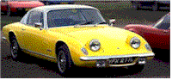
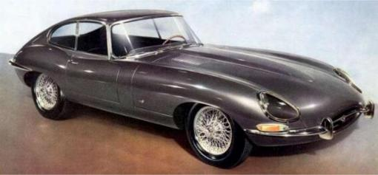
FESTIVAL of TRANSPORT 2014
Sunday May 25th 10am-5pm
Hammond Park Newton Longville

Vehicle Registration Form

ENTRANT |  | ENTRY
Name |  | Vehicle
Address |  | Model
 |  | Year of Manufacture
 |  | Registration Number
Post Code |  | Body Type
Telephone Number |  | For Official Use Only
Mobile |  | Entry Number | Class |  | Number
e-mail address

Tick Class most appropriate to above entry (one class only)
A |  | Cars 1900 - 1920
B |  | Cars 1921 - 1945
C |  | Cars 1946 – 1970
D |  | Cars 1970+
E |  | Military Vehicles
F |  | Commercial / PSV Vehicles
G |  | Agricultural Vehicles
H |  | Sport / Racing
K |  | Motor Cycle 1900 - 1965
L |  | Motor Cycle 1966 +

INSURANCE
The Festival site, at Hammond Park will be covered by Public Liability Insurance. It is in the owners and or driver’s best interest to ensure that any vehicle attending the event is properly insured for use on the public highway and the driver/s are properly licensed.

Pre entry Fees for Exhibitors……………………..£5.00 per car incl. driver
(on the day at the gate) £8.00 per car incl. driver
Pre entry fee exhibitor £4.00 Motorcycle incl. rider
(on the gate on the day) ………………………….£6.00 Motorcycle incl. rider
All Passengers/visitors ------------------------------ £4.00 Adults. (Children under 12 & Concessions £2.00)
Public car park on the day ……………………….£2.00 per vehicle EXCL all passengers

Please return this completed the entry form above and return it with a 9” x 6” S.A.E to:-
D Miller, 5 Church End, Newton Longville, Bucks. MK17 0AG
Further details are available on the NLFT website: www.festival-of-transport.co.uk

